SPOTV NOW
1. Launch Details​
Key Summary/USP​ | ​Launching the SPOTV NOW product page on the CelcomDigi website under the Lifestyle tab, with special pricing for CelcomDigi subscribers.  First-time subscribers using Pay via CelcomDigi (DOB) will enjoy a discounted rate for the first month, with standard pricing starting from Month 2.
Channels​ | - CelcomDigi App,  - CelcomDigi website (Lifestyle),  - SPOTV NOW Website,  - SPOTV NOW App

2. Product or Campaign Details
Offering Details | Customers subscribing to SPOTV will be charged RM5.75 for the first month, followed by RM11.50 per month thereafter.

3. Eligibility and Criteria
Eligibility & Criteria | CelcomDigi customer (Prepaid/Postpaid/Fibre)

4. Customer Journey (current journey / campaign only)
Customer Journey | SPOTV NOW (self-discovery)  Step 1: SPOTV NOW Website/App  Step 2: SPOTV NOW Purchase Page: User to select CelcomDigi as payment option  Step 3: Successful payment with Pay via CelcomDigi

5. Customer Communications (Active)
Active Comms  Help Centre | ENG:  https://help.celcomdigi.com/en/support/solutions/articles/70000663545-spotv-now  BM: https://bantuan.celcomdigi.com/en/support/solutions/articles/70000663544-spotv-now
Active Comms  Website | CelcomDigi (Lifestyle tab) > SPOTV NOW Product Page: https://www.celcomdigi.com/lifestyle/spotv  SPOTV NOW dedicated website:  https://spotvnow.com/celcomdigi

6. Internal Information
Visuals | 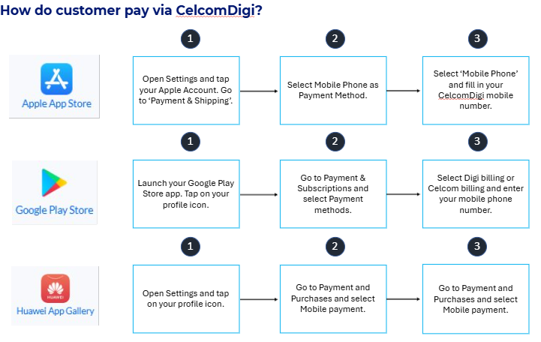
Internal FAQ

7. Reference Guide (Agent Guide, Scenario Handling and Other References)
Reference Guide
System Naming/
Product ID

